Abstract

VISUAL FEATURES OF INSCRIPTIONS.

An issue for EDB (and EAGLE)

Antonio, Enrico FELLE

Università degli Studi di Bari "Aldo Moro" -Italy

Email: antonio.felle@uniba.it

In these last years the amount of digital images of inscriptions increased very quickly: we do not need accurate textual descriptions of the so-called *anaglypha*, because we can directly see them. But we have to build a search-by-image, using photos and drawings but also tagging them with standardized - and shared - labels.

The issue of the "illustrated inscriptions" brings us to consider more broadly all the visual features of inscriptions, that were conceived as objects to see, not only to read.

**Keywords**

Early Christian Epigraphy, Byzantine Epigraphy, Middle Ages Epigraphy, Images, Symbols, Signs, Paleography, Stonecutters’ workshops

**1. "Illustrated inscriptions" by the Christians of Rome.**

In 2012, during a conference in Rome about Late Antique plates decorated with engravings, I presented a paper about the potentially very useful contribute that the Epigraphic Database Bari (EDB) could offer to study and to interpret the notion and the use of images (signs, symbols, figures and so on) by the Christians of Rome in Late Antiquity, by analyzing the inscriptions stored in the database [Felle 2013].

Then, the first datum was that only a quarter of these epigraphs displays images or generical non-alphabetical signs [Felle 2013, p. 101] (fig. 1).

**Fig. 1**. Percentage in EDB of the "illustrated inscriptions" (chart by A. E. Felle).

After storing in EDB other 10000 inscriptions, since 2012 to the present day, the percentage of figured inscriptions is still the same: then, I think that we are able to consider this datum enough sure; so we are able to partially correct the common idea that using images in written monuments is a recurrent, typical and characteristic feature of almost all the Early Christian inscriptions.

The second datum defined by the 2012 survey was the proportional decreasing of the use of different kind of images from the first decades of the IV century (the age of Constantine), when a huge and pervasive use of the so-called *signa Christi -* first of all the Chi-Rho monogram, with all its variations - prevails on all the other signs and figures [Felle 2013, 101-102].

Carlo Carletti explained this phenomenon as the result of a will to display *explicit* signs of a religious identity, such the Chi-Rho monogram is [Carletti 2008, 68-72; Felle 2007, 365-366]. But we have to underline that the phenomenon is not exclusive of Christian patrons. We observe more and more recurrent similar "signs of identity" also among inscriptions commissioned by Jews, not only in Rome but also in other contexts in Late Antiquity world where they were [Felle 2007, *passim*; Felle, in press].

Going back to the inscriptions by Christians, the use of *signa Christi*  in form of monograms strongly reduces the use of other christological signs or figures, as for instance the anchor: this one, very recurrent during all III century, disappears completely and very quickly, already in the very first decades of IV century [Felle 2012, 103] (fig. 2).

**Fig. 2.** Use of different images in inscriptions by Christians of Rome between III and IV cent. (chart by A. E. Felle)

Since its conception, EDB recorded the presence and the different kinds of various *signa Christi*, both by a checkbox and in the text field, with *standardized* descriptions, with the aim to easily retrieve them in the database and to get valuable results from structured queries about their recurrence.

The results of the 2012 study were mainly of *quantitative* nature; today, by the existing large repositories of images in EDB – as like in general in EAGLE and in other similar epigraphic projects – we can improve the *qualitative* analysis of this and other features of Late Antique inscriptions.

First of all, we have to say that in EDB we faced huge difficulties about the treatment of images other than *signa Christi*, or generally other non-alphabetical signs, or also captions related to figures on the slabs, and so on. Indeed, at the moment we are still not able to automatically obtain by EDB a *structured* index of the repertoire of the images. As in other epigraphic databases, in EDB they are recorded directly reporting their descriptions as like they are in printed editions (sometimes very old, as the first volumes of ICVR, for instance); there, in absence of pictures, the so-called *anaglypha* are concisely described by simplified and repetitive *clichées* to suggestthe depicted subjects to the readers (fig. 3) or by brief descriptions in Latin in transcriptions or also in the commentaries (fig. 4).

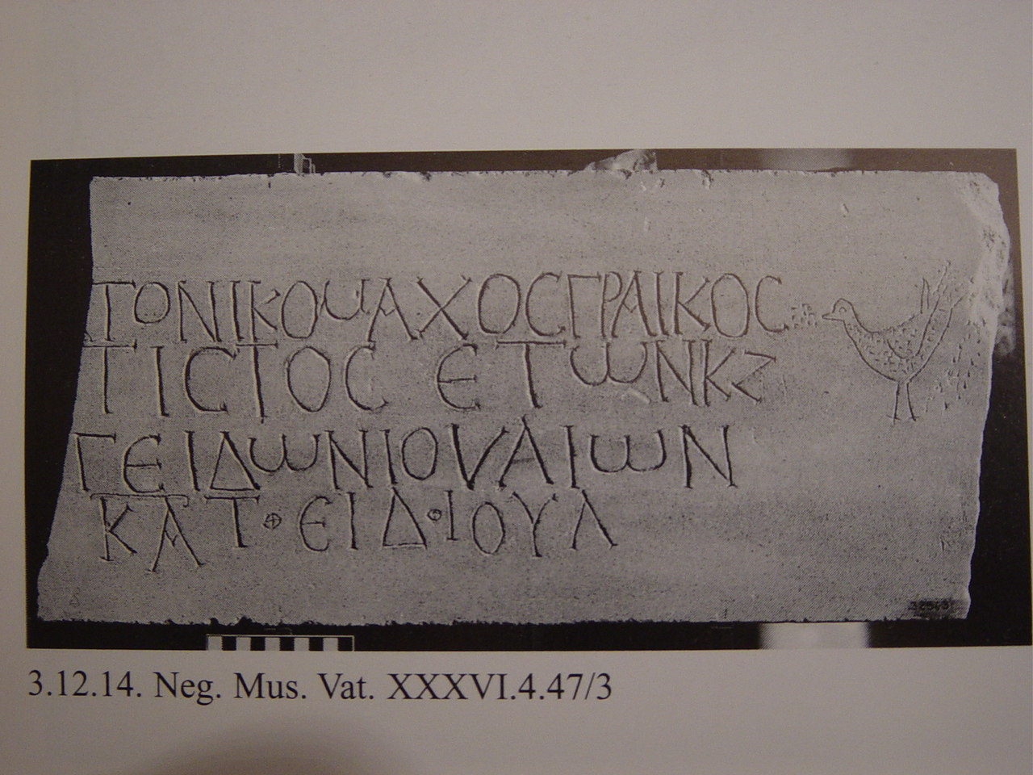

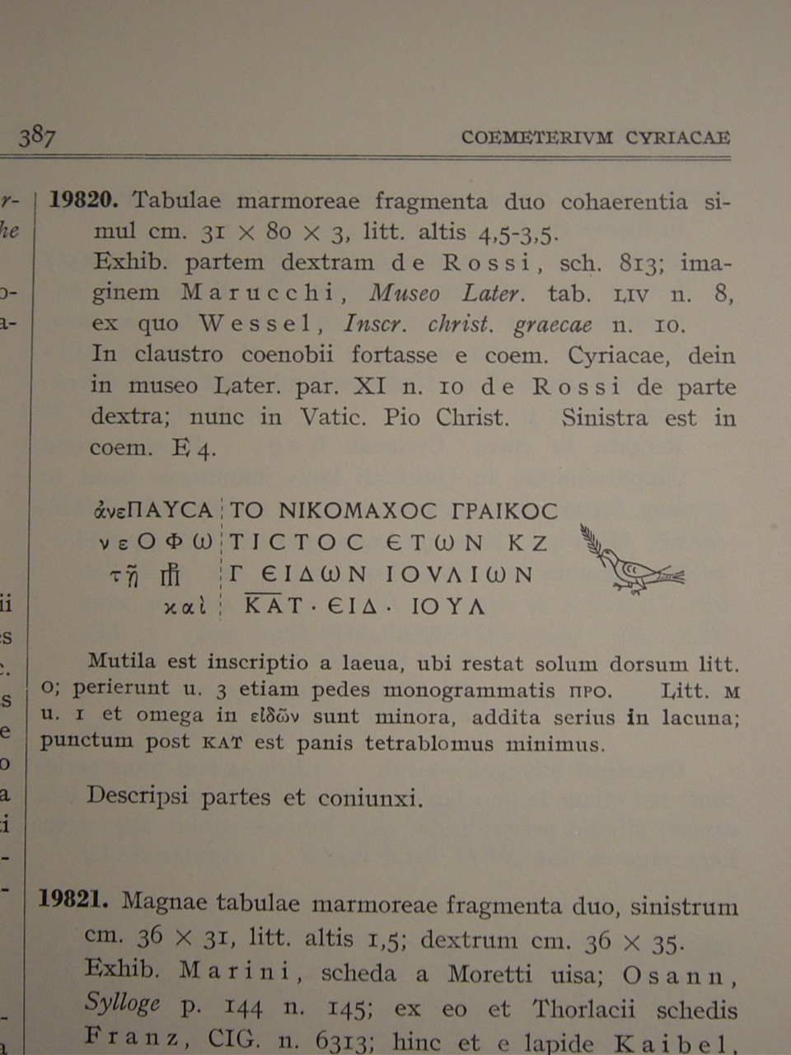

**Fig. 3.** Rome*,**coemeterium Hippolyti,* now in the Vatican Museums. Photo (from *Iscrizioni* 1997, sch. 3.12.14) and edition in ICVR, VII 19820.

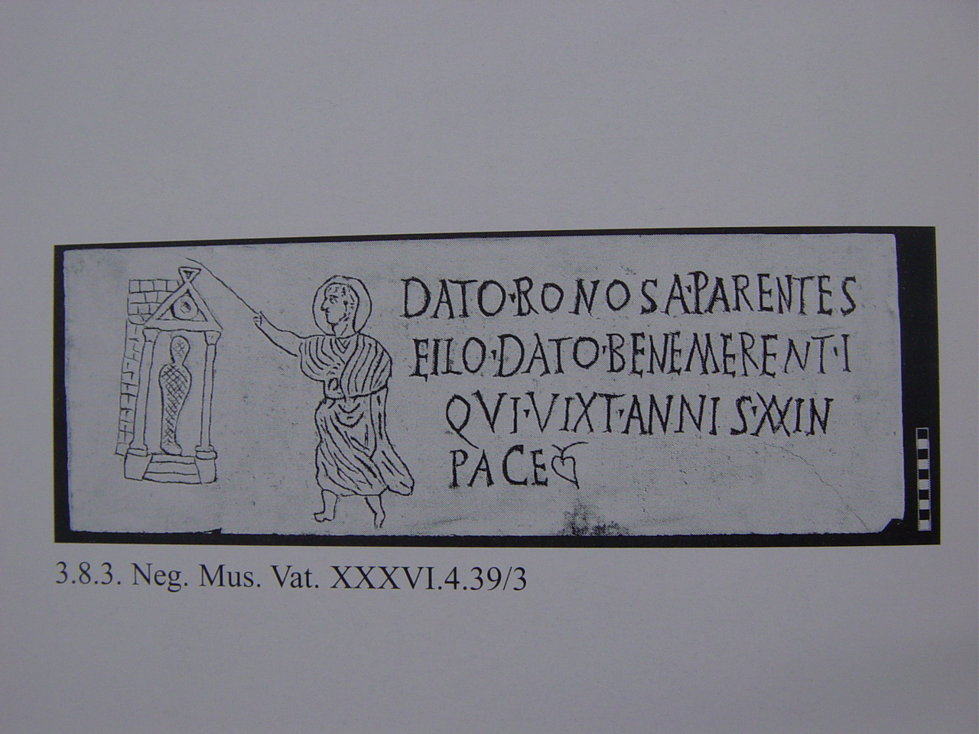

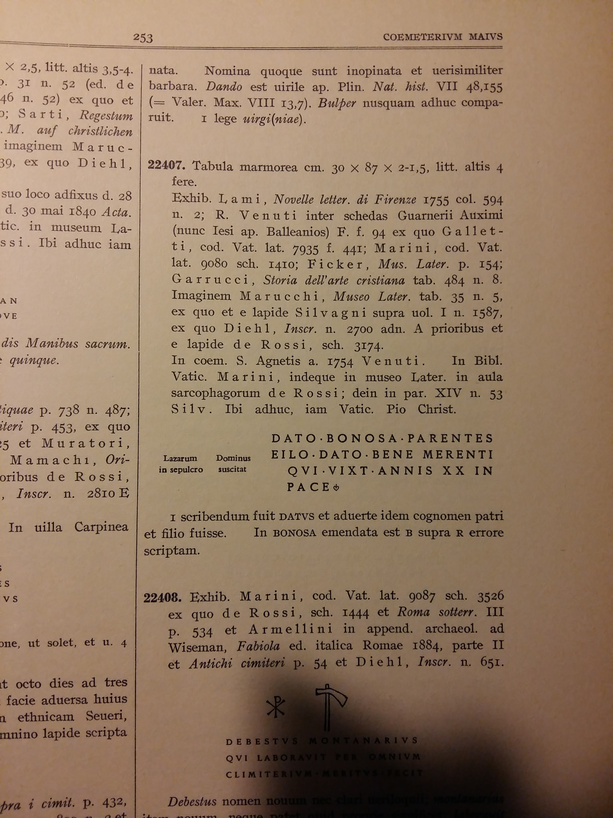

**Fig. 4.** Rome*,**coemeterium Maius,* now in the Vatican Museums*.* Photo (from *Iscrizioni* 1997, sch. 3.8.3) and edition in ICVR, VIII 22407.

Often, these descriptions are different although indicating the same subjects: in the ICVR, the reason of this disomogeneity is not only the *longue durée* of the realization of the corpus (seventy years, since 1922 to 1992, when the last published volume, the tenth, appeared) but also a refined textual *variatio.* Surely it can be appreciated in printed editions but, for the aim of our digital archives, produces real difficulties.

Some examples: in EDB different verbal descriptions about the some subject are recorded, such as *avis uvam pascitur* (*e.g.* ICVR, III 8114a, b, c, e)*,* or *avis uvas pascitur* (ICVR, III 8004b)*;* or also *avis racemum carpens* (ICVR, IX 24020)*, avis racemum carpit* (ICVR V, 14157)*, avis racemum pascitur* (ICVR, V 15194), *avis racemum rostro carpit* (ICVR, IV 10934): it is not easy to perceive some difference)*.* However, this *variatio* prevents right results in retrieving data in our database.

Moreover, recording in EDB descriptions with different words for the same illustrated subject, such as "*avis, racemus*" (EDB 19827: ICVR, III 9311, see fig. 5a) or "*avis cum racemo*" (EDB 24933: ICVR, III 8044, see fig. 5b)we are not able to retrieve all the occurrences of this same subject, because they are recorded (both n ICVR and in EDB) in different ways.

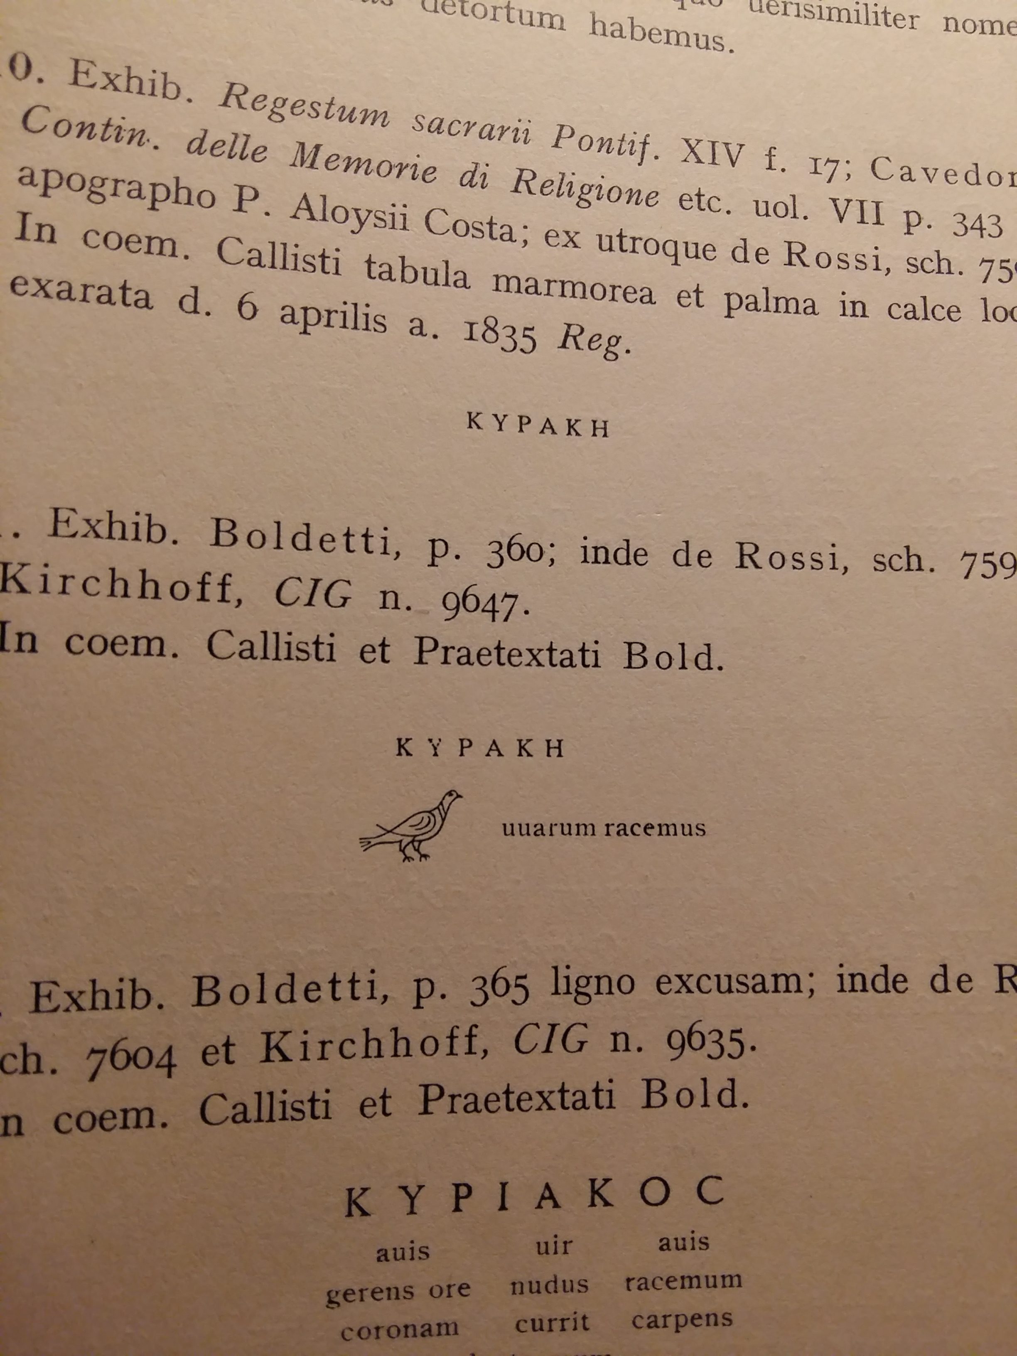 a b 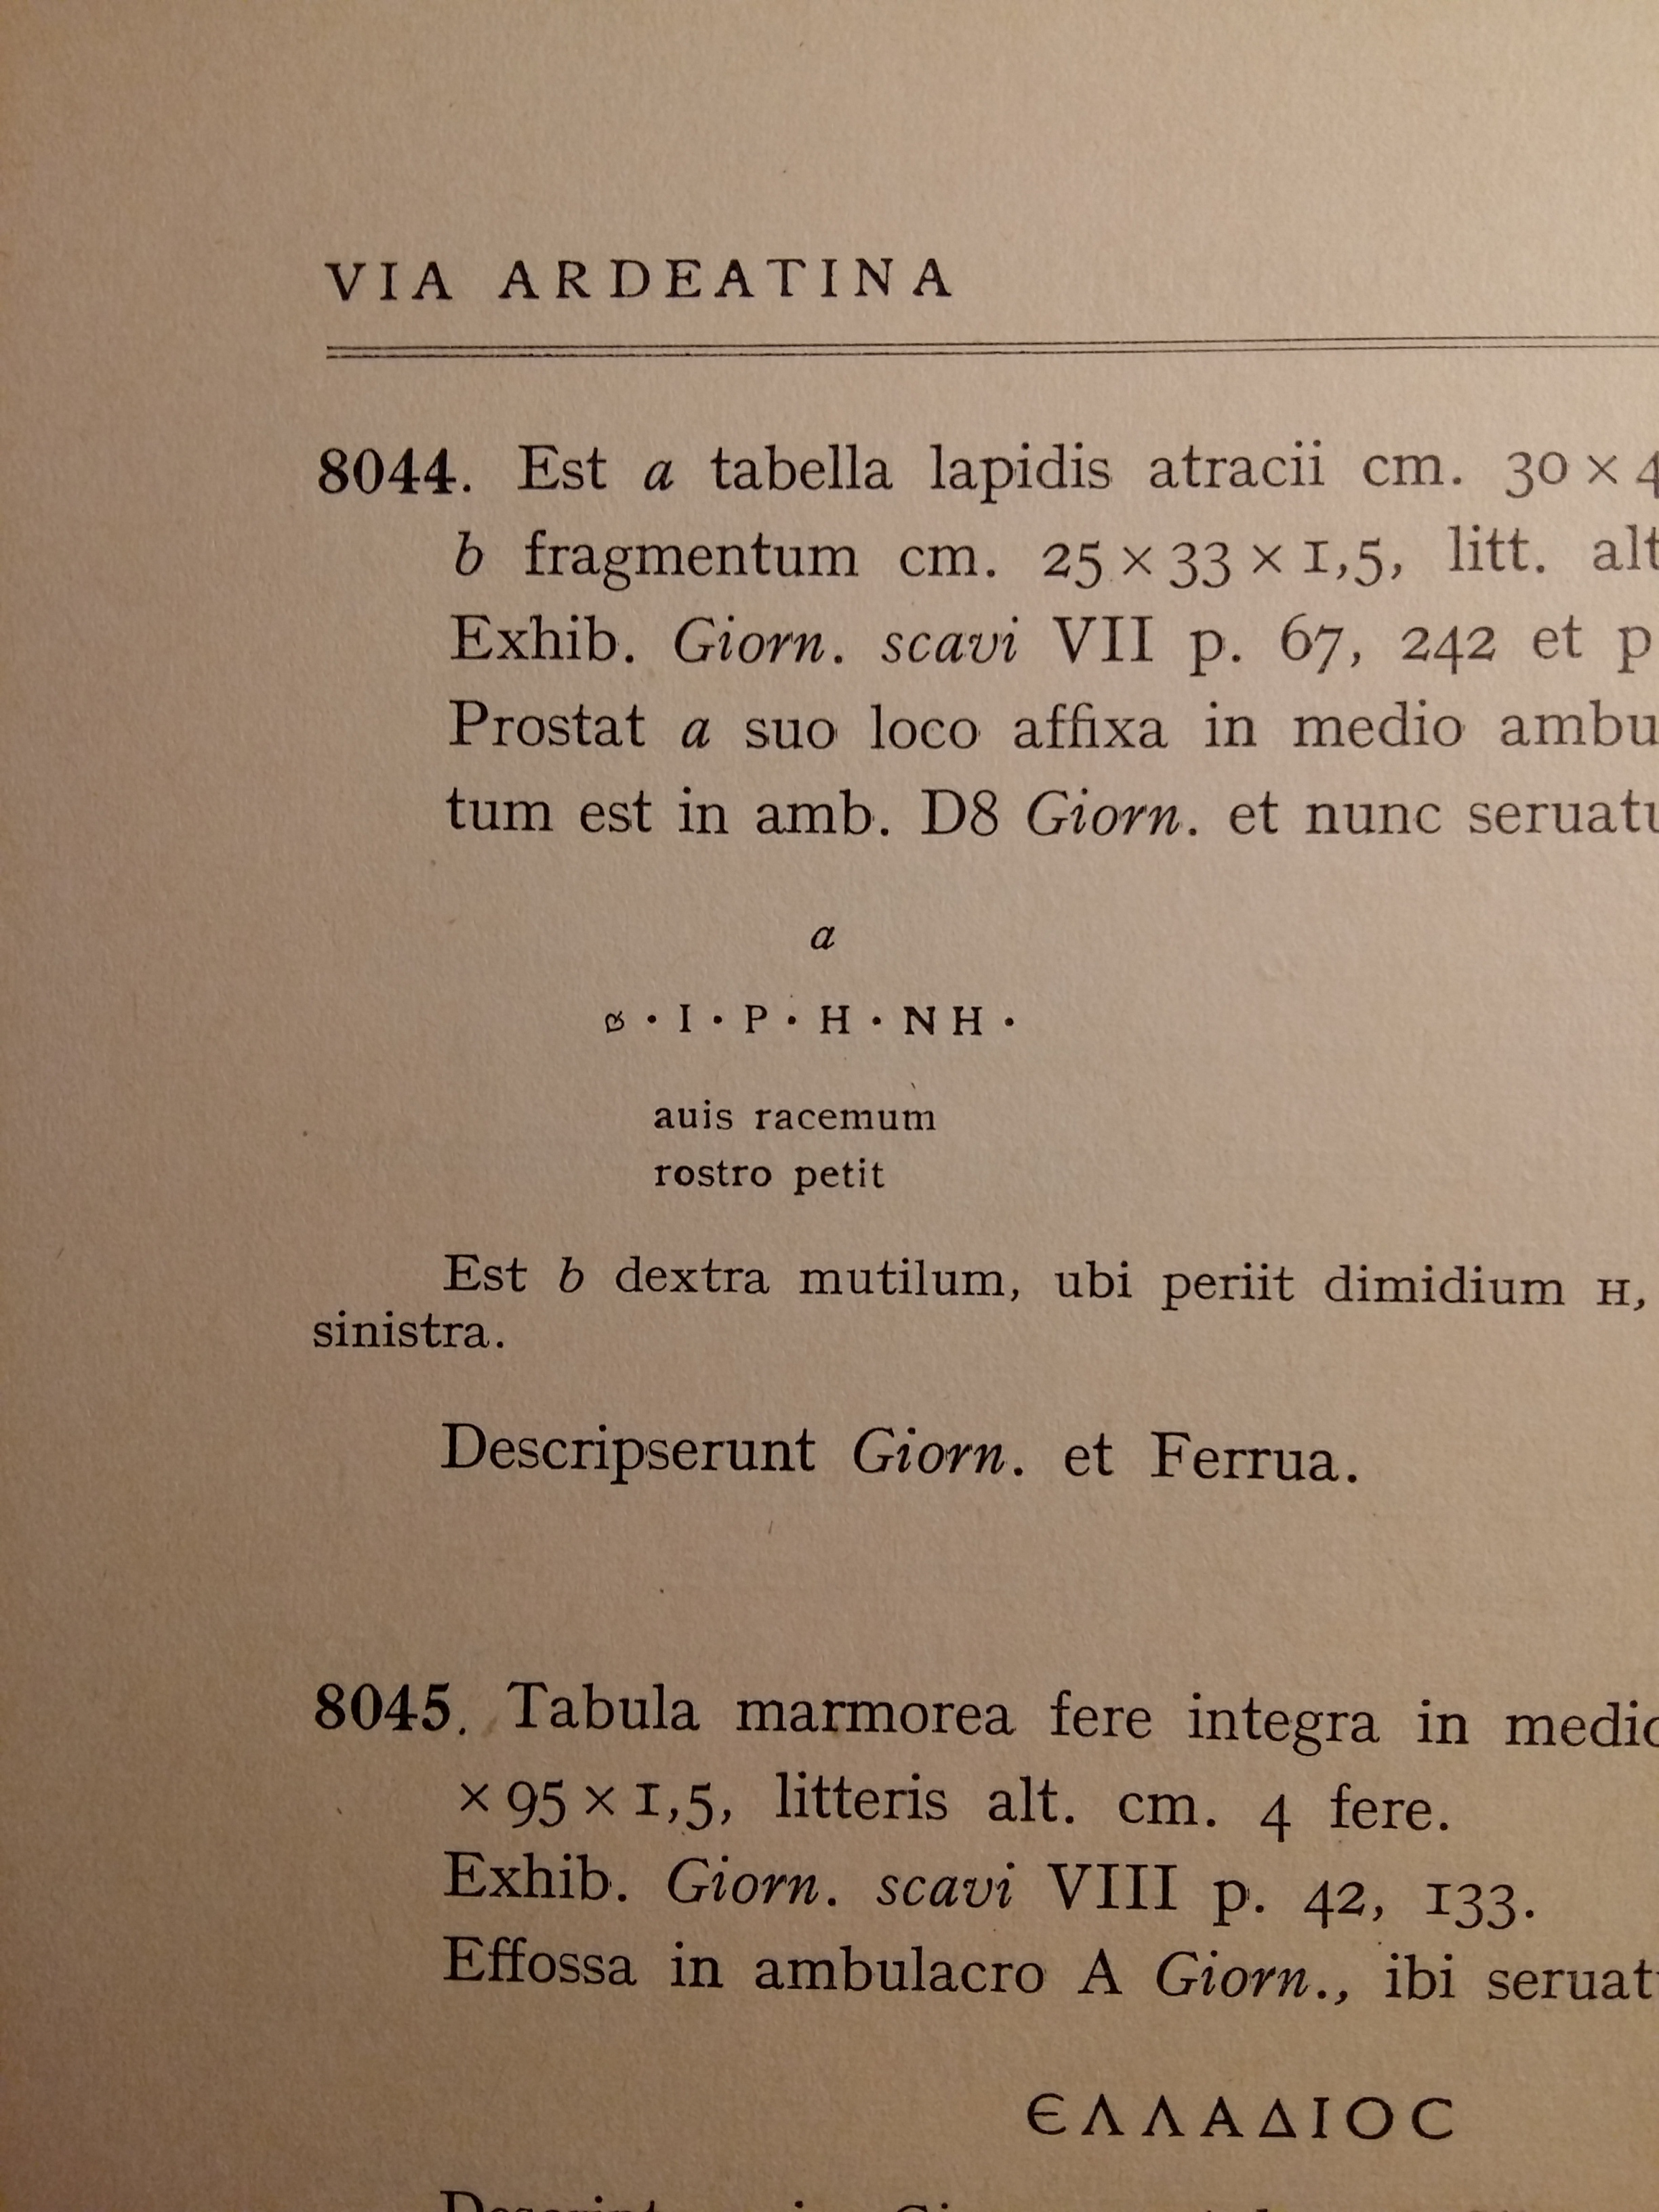

**Fig. 5**. Rome, catacomb of Domitilla. Edition of ICVR, III 9311 (a) and ICVR, III 8044 (b).

This ambiguity prevents to retrieve all the occurrences of the same illustrated subjects and then they adulterate the result of our queries: I think that we have to correct as soon as possible this ambiguity, in order to establish an unique way to describe the *anaglypha*.

One can say that the present ease to obtain and to use digital pictures of the inscriptions overtakes this issue: surely that's true. But, I do not entirely agree with this point of view.

In these last years - also with the kind help by the Photographic Archive of Papal Commission of Sacred Archaeology (http://www.archeologiasacra.net/pcas-web/) - the amount of images available in EDB increased very quickly: this is surely an advantage in respect to the situation of only three years ago. At the present day and more over in the future, we no longer need *accurate* textual descriptions of the *anaglypha*: we can directly *see* them. But, the possibility to easily view a photo or a drawing of an inscription does not solve the issues related to search and to retrieve inscriptions bearing given kinds of image, or specific signs, and so on.

The relative high occurrence of images in Christian inscriptions drives EDB team to try to build a search-by-image, using photos and drawings, but also tagging them with standardized labels. A “high definition” analysis of non-verbal language of the inscriptions by Christians of Rome in Late Antiquity surely needs photos, drawings, and so on, but mostly needs a logical, structured, hierarchically ordered taxonomy of all non textual elements defined by controlled, firm and shared vocabulary: a *thesaurus imaginum*[1], that can be a suitable tool also to trail the activity of different stonecutters’ workshops that served – in the case of EDB inscriptions - the various users of the Roman Christian catacombs.

**2**. **Visual features of the 'written monuments'.**

The issue of the "illustrated inscriptions" brings us to consider more broadly the visual features of inscriptions overall. The ancient epigraphs are conceived not only as texts to be read (very few people were able to do it) but also - and, maybe, firstly - as objects to be seen. I think that we have to realize this perspective - common in Christian epigraphy studies after all - to understand the communication power of this communicative *medium*. Indeed, the topic has been assumed as main theme of the last International Congress of Greek and Latin Epigraphy in Berlin in 2012 [*Öffentlichkeit* 2014]; very recently, a just published volume collects various essays about this same topic just about the Late Antique, Medieval (both Christian and Islamic) world, where this notion of the inscriptions as 'written monuments' stands out with strong evidence [see Eastmond 2015].

In our projects - we have to admit it - the notion that inscriptions are *essentially* texts is still largely prevailing: but now we can - consequently, we must - to increase our capability to represent, to record and so to investigate also other, visual features of inscriptions.

**2.1. Positioning**

First of all, I think to the positioning of the epigraphs in the contexts for which they were created. About EDB, we already presented in the EAGLE Conference in Paris in 2014 a first attempt to record and to describe the exact positioning of the inscriptions still found in their original spot, by sharing data with the Domitilla-Projekt (by the Österreichische Akademie der Wissenschaften and the Deutsches Archäologisches Institut) focused to the frescoes of the catacomb of Domitilla along via Ardeatina, the largest one in Rome suburb [Felle - Zimmermann 2014]. The positive collaboration between our two projects continued: now we are able to offer to EDB users to view on the updated map of the catacomb of Domitilla the distribution of the inscriptions still *in situ* in the four levels of the subterranean cemetery: one can use them as reliable documents to (re-)consider the history of the complex, to confirm or to deny the ideas about chronology of its excavation and of its frescoes and about the using of the different zones of the catacomb.

**2.2. Materials and shape**

Materials and shape of the written objects communicate im-mediately, *to all*, before the inscribed texts. Because now we can do it, we have to display to the users of our projects the real communicative power of the inscriptions, that assume much more meaningfulness when we can see them than when we can read their only texts in a library. By pictures and 3D rendering of the places where the epigraphs were arranged we should be able also to provide virtual images of inscriptions - also lost or incomplete - conceived to be seen and read exactly there. An effective example can be the dedication by pope Damasus (366-384) to the martyr *Ianuarius* in the catacomb of Praetextatus on the via Appia (fig. 6).

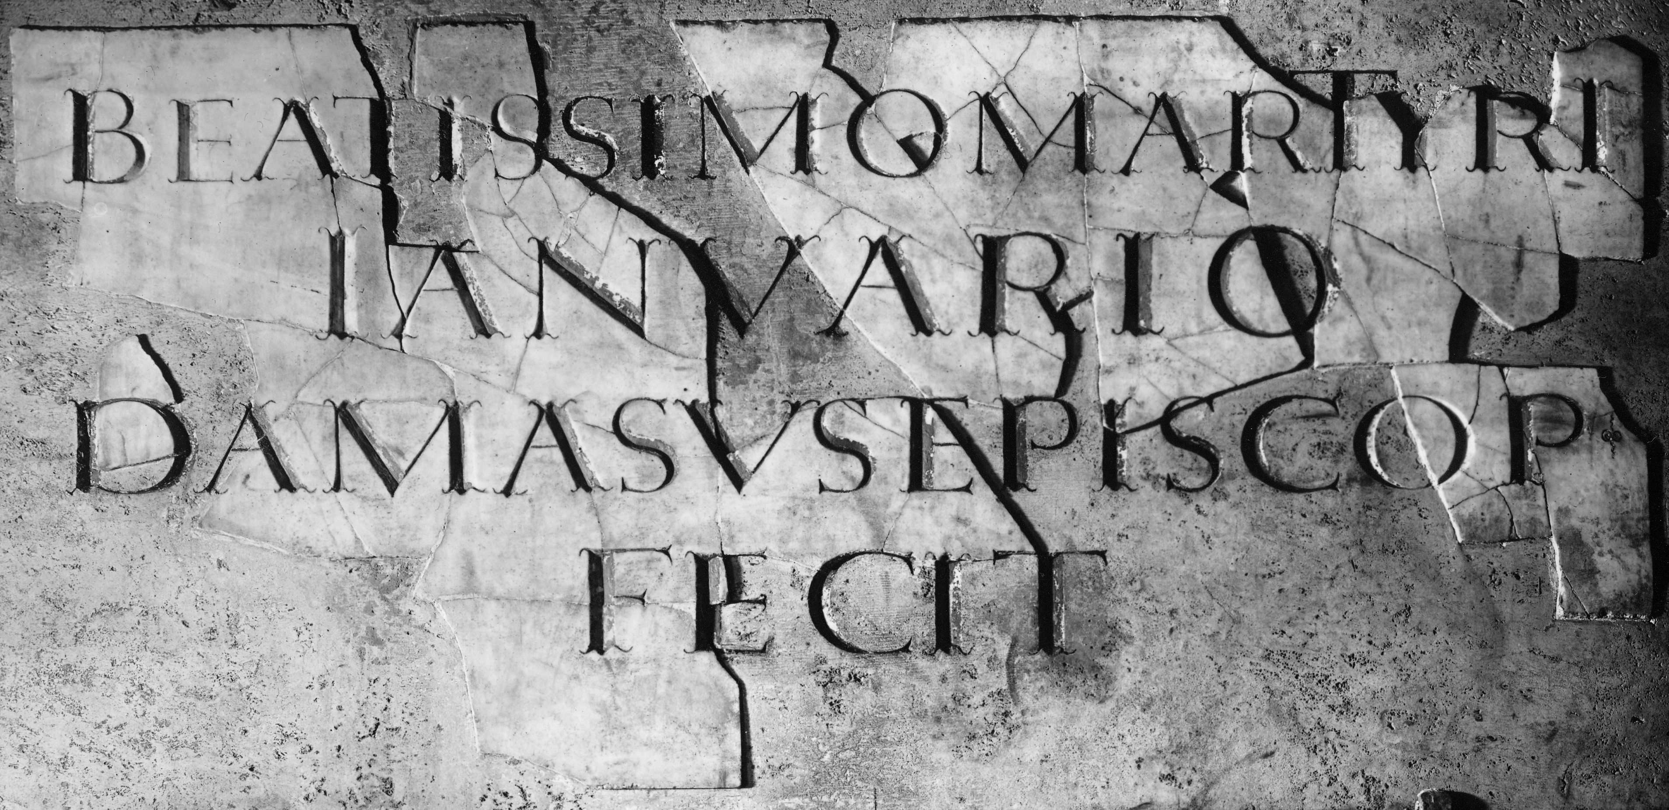

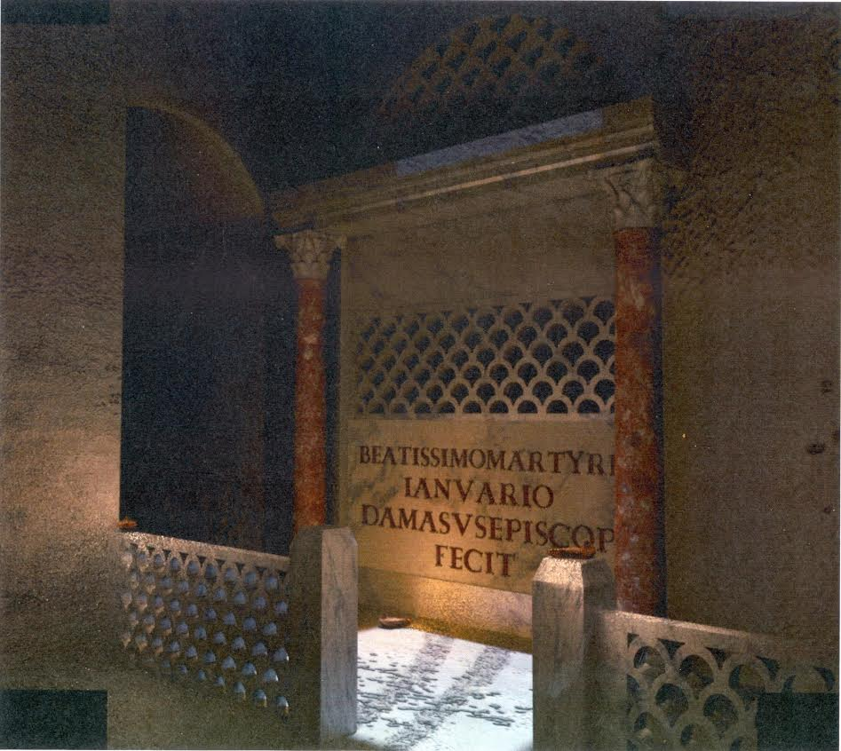

**Fig. 6.** Rome, catacomb of Praetextatus. Damasus’ dedicatory inscription (ICVR, V 13871) for the martyr *Ianuarius* (Photo: PCAS; 3D rendering: G. De Felice).

The bishop of Rome reaches his aim to capture the gaze also of *illiterate* faithfuls by placing a very large slab of white marble over the tomb of the martyr, well-lighted by a skylight made on purpose, in strong contrast to the darkness of the neighbouring galleries of the subterranean cemetery.

Also the text is aimed at the same goal: the dedication is brief and simple, inscribed using a special writing, very carefully carved by using a font specially elaborated for Damasus' inscriptions by the fashionable designer Furius Dionysius Philocalus. The contrast with the common inscriptions in the catacombs, often made by reused marble pieces or bricks, and very often (not always!) written with rough letters, is impressive. The bishop's intervention is more meaningfully revealed to all by the visual features of his inscriptions than by their only (metrical or not) texts.

This notion about written monuments is more and more diffused in Western Early Middle Ages and also in Byzantium: one has no need to read, to perceive the actual and effective messages displayed by inscriptions placed within the fabric of the walls of Byzantine cities, such as Constantinople or Thessaloniki (fig. 7).

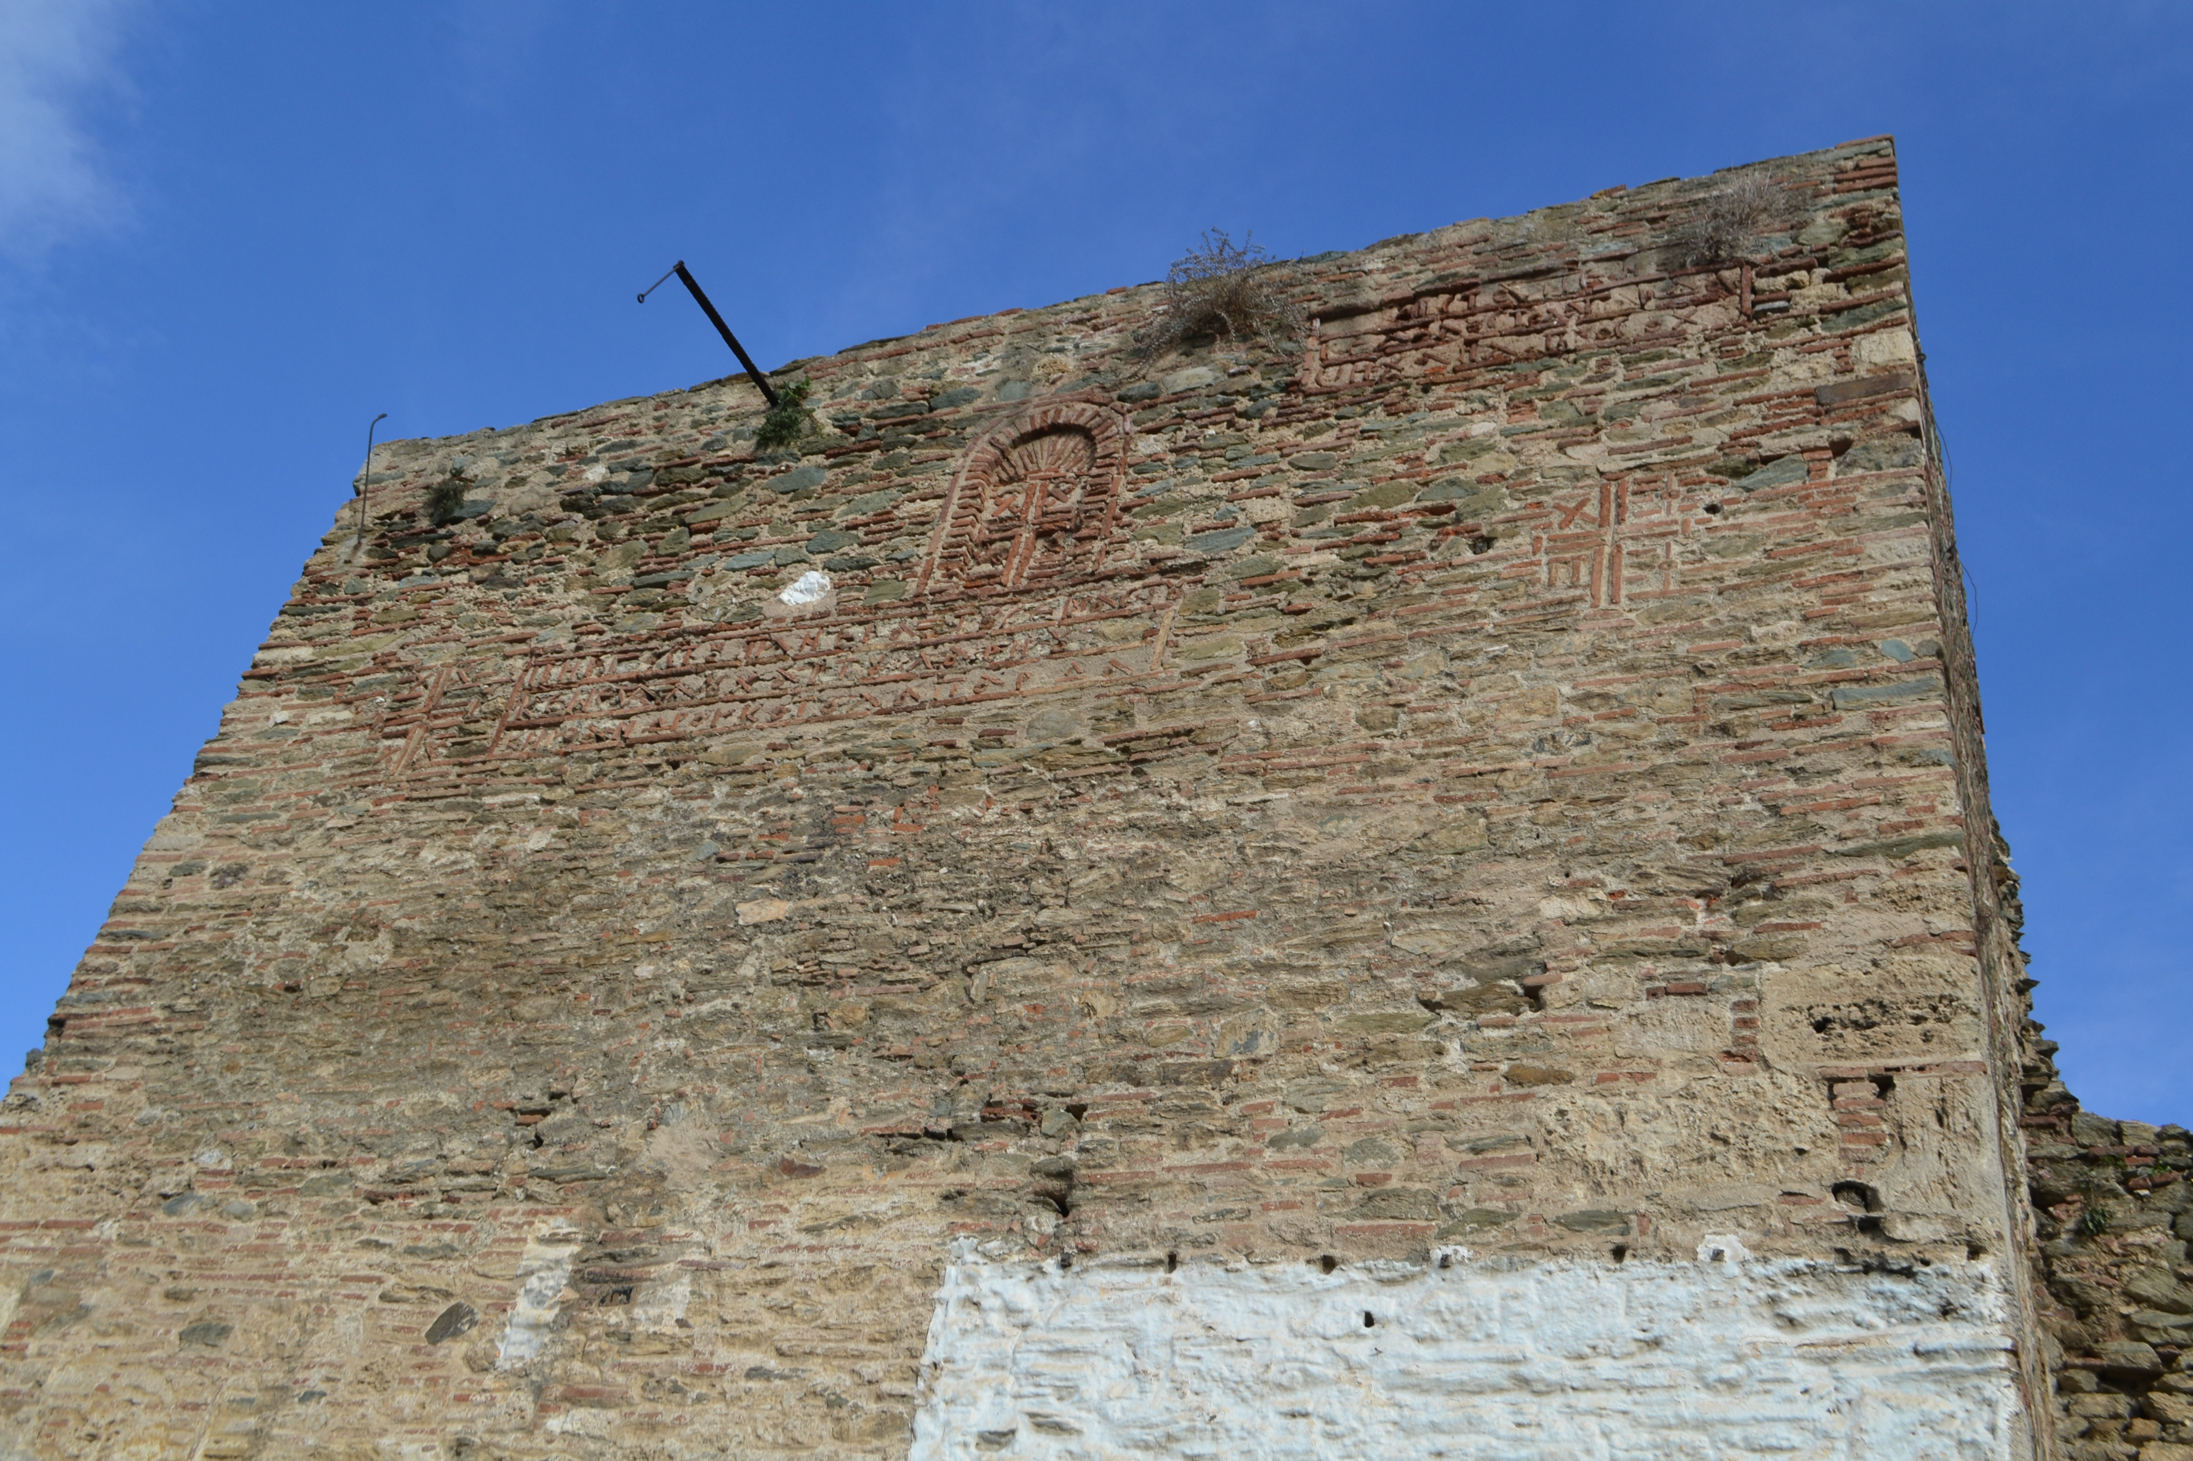

**Fig. 7.** Thessaloniki, city walls. Inscriptions in the masonry of a tower near Eptapyrgion (photo: A. E. Felle).

There, the inscriptions are not carved in marble slabs or stone blocks, but they are realized with the same materials of the walls: simple bricks, but disposed to obtain letters *and* signs *and* symbols, visible also from afar. The inscriptions explain the walls; the walls speak its *raisons d'être* by the inscriptions, that are in different cases rich of abbreviations, closed to the reading but open to the sight: writing appears *intrinsically* significant. In my opinion, this notion is clearly demonstrated by the unnecessary captions in the icons and in the images of martyrs (fig. 8), where - on closer view - the inscriptions are completely useless, if we continue to consider them only as texts to be read.

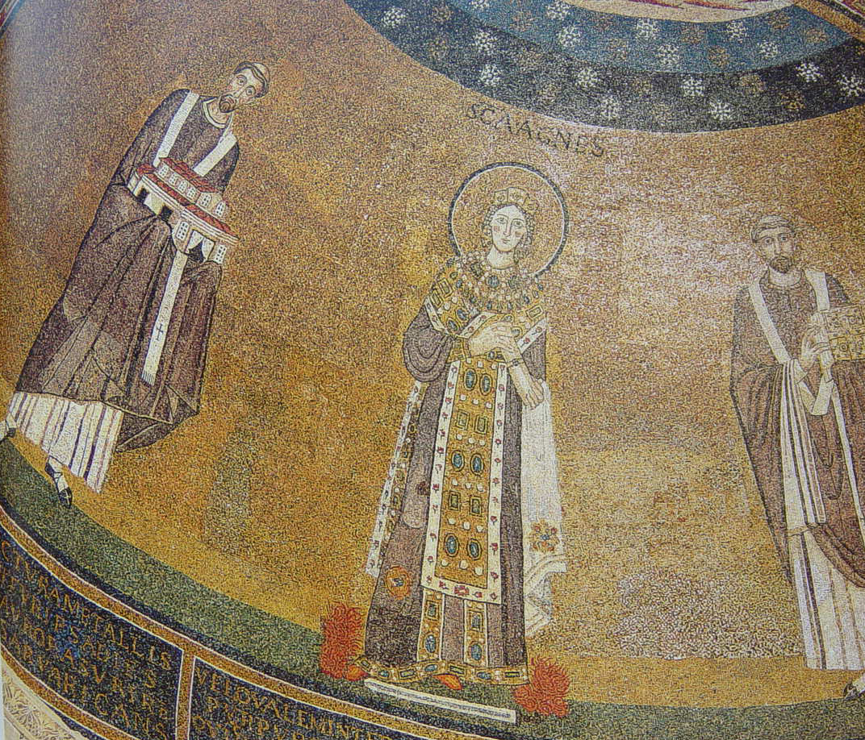

**Fig. 8.** Rome, basilica of the martyr Agnes on the via Nomentana. Apse mosaic with the image of the martyr with the “useless” caption *s(an)c(t)a Agnes* (photo: A. E. Felle).

**2.3. Relationship with the context**

Indeed - more over in Late Antiquity and Middle Ages - readability of the texts is not the main property of inscriptions: rather, the main condition appears their relationship with their contexts. An incisive example can be offered by the Christian inscriptions bearing biblical quotations [cfr. Felle 2006]: in the middle of the bronze plating of the marble lintel over the Great Door of the Royal Gates of the Haghia Sophia in Constantinople, an empty throne is occupied by an open *codex*, according to the words by Kähler, "the only extant plastic composition dating from the founding period of the church" [Kähler 1967, pp. 29-30; 32 taff. 22; 62] (fig. 9).

**Fig**

On the open *codex* is inscribed a focused - but barely readable - quotation from John 10, verses 7 and 9, where Jesus indicates himself as *the gate*:

John 10.7*: Εἶπεν οὖν πάλιν ὁ ᾿Ιησοῦς, ᾿Αμὴν ἀμὴν λέγω ὑμῖν ὅτι ἐγώ εἰμι ἡ θύρα τῶν προβάτων. (Therefore Jesus said again, ‘Very truly I tell you, I am the gate for the sheep);*

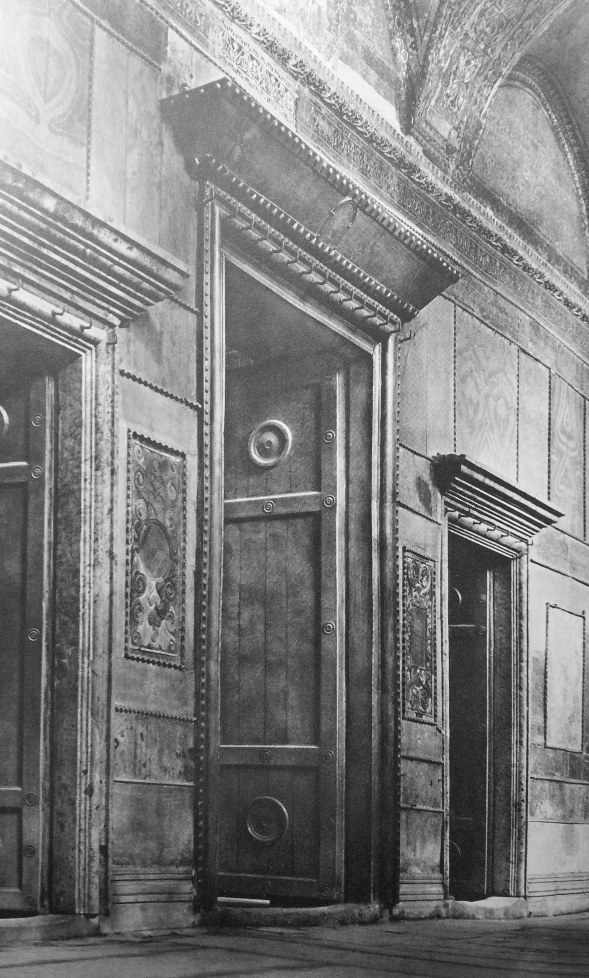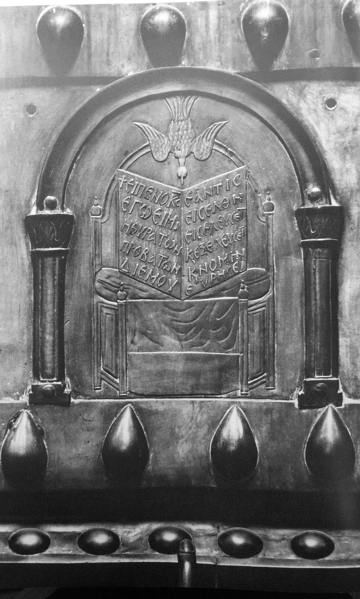John 10, 9*: ἐγώ εἰμι ἡ θύρα· δι' ἐμοῦ ἐάν τις εἰσέλθῃ σωθήσεται καὶ εἰσελεύσεται καὶ ἐξελεύσεται καὶ νομὴν εὑρήσει ( 9I am the gate; whoever enters through me will be saved.[*[*a*](https://www.biblegateway.com/passage/?version=NIVUK&search=John%2010#fen-NIVUK-26491a)*] They will come in and go out, and find pasture).*

**Fig. 9**. Istanbul, Hagia Sophia. On the left, the Royal Gates in the narthex. On the right, the particular of the image of the throne with open inscribed *codex* above the lintel of the central gate (from Kähler 1967).

This the text of the inscription [Felle 2006, n. 505]:

((crux)) εἶπεν ὁ κ(ύριο)ς | ἐγώ εἰμι | ἡ θύρα τῶν | προβάτων· | δι᾿ ἐμοῦ || ἐάν τις | εἰσέλθῃ | εἰσελεύσετ(αι) | κ(αὶ) ἐξελεύσετ(αι) | κ(αὶ) νομὴν | εὑρήσει.

The archeological context and the mirate positioning make tangible, concrete, the sacred words; and the real presence (not necessarily the readability) of the sacred words give proper and strong sense to their material support and to entire context, the Royal Gates of the Great Church of Constantinoples [Felle 2015, p. 320 and *passim*].

**2.4. Writing**

Scarce or null readability does not imply low quality of the appearance of writing: rather, the writing appears intrinsecally meaningful such as visual element of the equipment of a simple or rich funerary monument or of a cultual building. Then, we have to face the issue of the description of the writing not only from the necessary point of view of paleography ( we are still waiting for a shared and controlled vocabulary of paleographical definitions), but also in order to perceive and to understand its non-verbal significance: by its disposition, direction, shape. The notion of the inscriptions in the Islamic world, where often the letters are also - and maybe firstly - images (they are used as decorative friezes, architectural ornaments, figures) and their clearity and readability are not considered as necessary, can help us to evocate this feature of the writing (fig. 10).

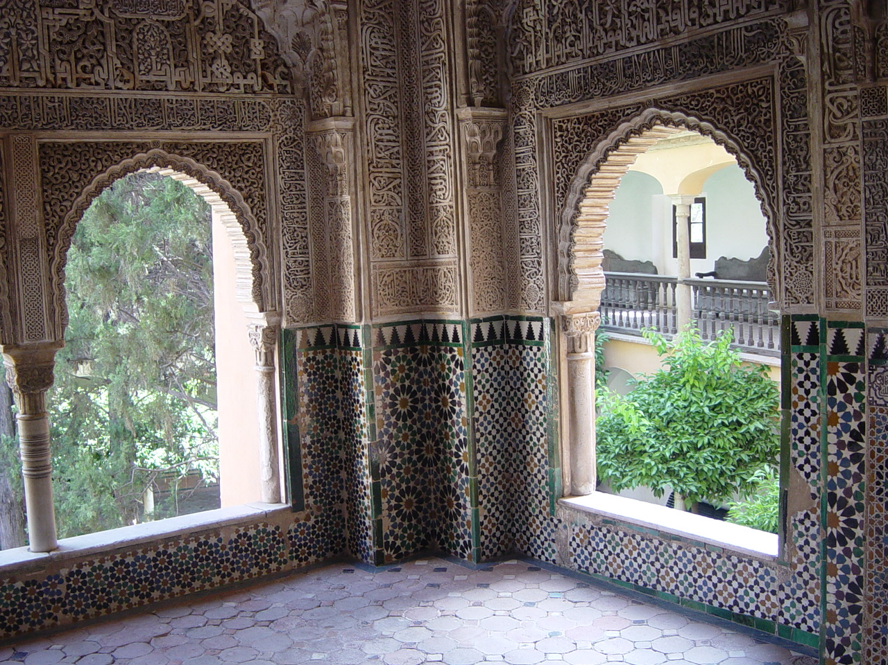

**Fig. 10**. Granada, Alhambra. An example of the writing as decorative frieze and architectural ornaments (Photo: A. E. Felle)

**3. Conclusions**

The ancient inscriptions actually belong to civilizations where the literacy - with very few exception - was very far from our standard: to see an inscription with the same point of view of the most part of the citizens in Roman Empire - and mostly in Late Antiquity - we have to become, in some way, illiterate.

In conclusion: we have to consider in digital descriptions of the inscriptions some their "visual features" that in our projects - first of all in EDB, of course - are not too considered, although they are very significant. We need, about encoding these non-verbal features, the same positive results that by Epidoc we reached in encoding the texts: a hard challenge.

Bibliography

Carletti 2008 C. Carletti, *Epigrafia dei cristiani in Occidente dal III al VII secolo. Ideologia e prassi*, Bari 2008.

*Iscrizioni* 1997 *Le iscrizioni dei cristiani in Vaticano*, a cura di I. Di Stefano Manzella, Città del Vaticano 1997.

Eastmond 2015 A. Eastmond (ed.), *Viewing Inscriptions in the Late Antique and Medieval World*, Cambridge University Press, New York 2015.

Felle 2006 Biblia Epigraphica*.* *La Sacra Scrittura nella documentazione epigrafica dell’*Orbis christianus antiquus *(III-VIII secolo)* [ICI, Subsidia, V], Bari 2006.

Felle 2007 A. E. Felle, *Judaism and Christianity in the light of epigraphic evidence (3rd-7th cent. C.E.)*, Henoch 29, 2007, pp. 354-377.

Felle 2013 A. E. Felle, *L'apporto dell'Epigraphic Database Bari (EDB) all'analisi dell'apparato figurativo delle iscrizioni dei cristiani di Roma*, in *Incisioni figurate della Tarda antichità. Atti del Convegno di Studi (Roma, 22-23 marzo 2012),* a cura di F. Bisconti - M. Braconi, Città del Vaticano 2013, 99-112.

Felle 2015 A. E. Felle, *Esporre la Scrittura. L'uso di testi biblici in epigrafi d'ambito pubblico fra tarda antichità e prima età bizantina (sec. IV-VIII),* Antiquité Tardive 23, 2015, 311-328.

Felle (in press) A. E. Felle, *Documenti epigrafici di committenza ebraica. Omologazione e alterità,* in M. Pesce - A. Destro (edd.), *Texts, Practices, and Groups. Multidisciplinary approaches to the istory of Jesus Followers in the first two centuries. First Annual Meeting of Bertinoro (2-4 October 2014)*, [Judaïsme Ancien et Origines Chrétiennes, 1], Turnhout 2016, in press.

Felle,

Zimmermann 2014 A. E. Felle, N. Zimmermann, *Epigraphy, Art History, Archaeology.* *A Case of Interaction between Research Projects: The Epigraphic Database Bari (UniBa, Italy) and the Domitilla Projekt (ÖAW, Austria - DAI, Deutschland),* in *Information Technologies for Epigraphy and Cultural Heritage. Proceedings of the First EAGLE International Conference* (Paris, September 29-30 - October, 1, 2014), Roma 2014, 75-96.

Kähler 1967 H. Kähler, *Die Hagia Sophia. Mit einem Beitrag von Cyril Mango über die Mosaiken*, Berlin 1967.

*Öffentlichkeit* 2014 *Öffentlichkeit - Monument - Text*. *XIV Congressus Internationalis Epigraphiae Graecae et Latinae. Akten* *(Berlin, 27.-31. August 2012),*hrsg.Eck W.-Funke P. et alii*,* Berlin2014.

1. Surely the experiences of other projects can be useful to this aim: I think for instance to the solutions presented during the VIth EAGLE International Event in Bari by the lecture offered by Rebecca Benefiel and Holly Sypniewski about the *Ancient Graffiti of Herculaneum* project.